RESOLUTION 15-37
A RESOLUTION TO AUTHORIZE THE PURCHASE OF (7) NEW POLICE VEHICLES FOR THE POLICE DEPARTMENT

Whereas, the Spring Hill Police Department was allocated to purchase 6 new police vehicles in the current 2014-15 budget; and
Whereas, due to damage to one vehicle during this current budget, an additional vehicle will need to be replaced from an insurance claim; and
Whereas, the Spring Hill Police Department advertised an RFP and received bids for (7) Chevrolet Caprices on April 27, 2015 and has reviewed specs and pricing of other police vehicles; and

Whereas; City staff has reviewed said proposals and has made a recommendation to the Budget and Finance Advisory Committee;
NOW, THEREFORE BE IT RESOLVED, that the City of Spring Hill authorizes the purchase (7) Chevrolet Caprices from Lyon's Chevrolet for a total cost of $299,208.00 as recommended by the Budget and Finance Advisory Committee on May 4th, 2015.

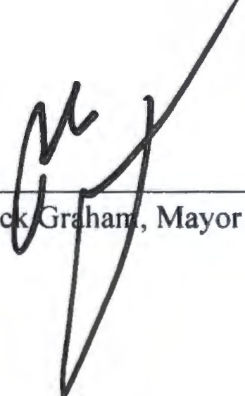Passed and adopted by the Board of Mayor and Aldermen of the City of Spring Hill, Tennessee on the 18th day of May 18th, 2015.

Ri
A ST:
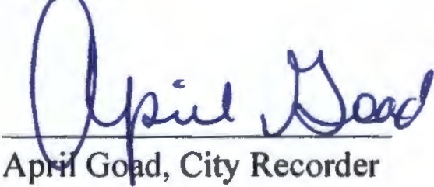

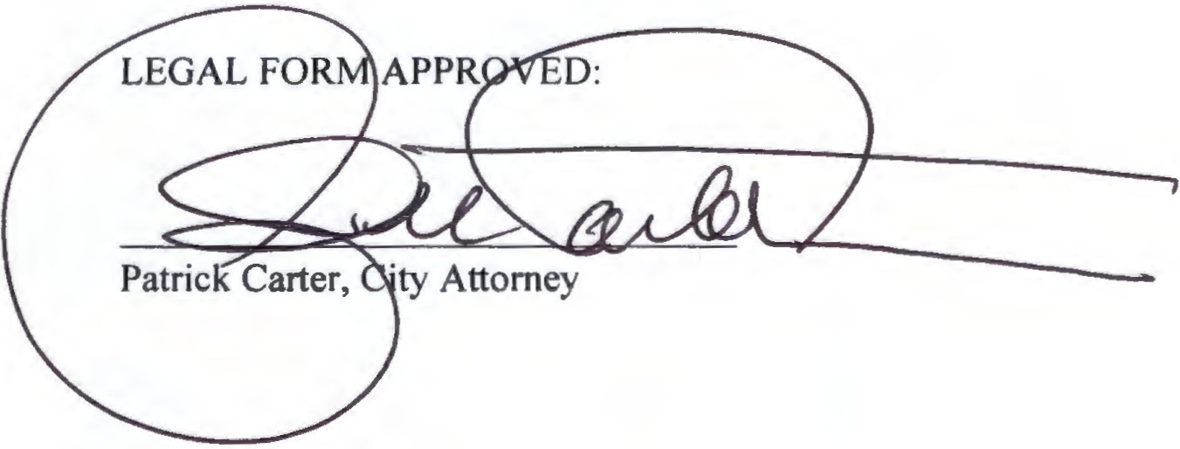



T E N N_ E,.,S.S E E

REQUEST: Approval of Resolution 15-37

SUBMITTED BY: Victor Lay, City Administrator
Don Brite, Chief of Police
DATE: May 4th, 2015

RE: Purchase of Police Vehicles ATTACHMENTS: Description of any attachments

PURPOSE:
The Police Department was allocated to purchase 6 new police vehicles under the current budget. We received an insurance claim for another vehicle that was declared a total loss as the result of the vehicle catching on fire. Total of (7) vehicles to be purchased.

BACKGROUND:
This purchase is to maintain our fleet by purchasing new vehicles to replace older model vehicles in our fleet.

FINANCIAL IMPACT:
??????

STAFF RECOMMENDATION:
Purchase any vehicles available?????

ACTION REQUIRED (INCLUDE DEADLINE /PRIORITY):
Resolution for purchase. Will need to do resolution for equipment in June. Also Finance Department will need to obtain funding.

Page 1of 1

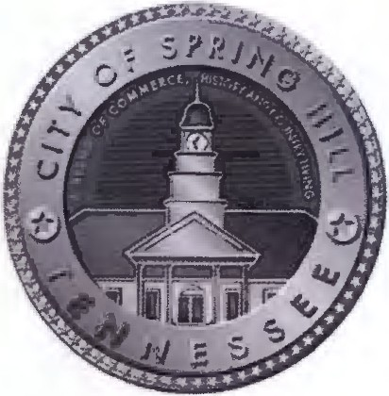

DEPARTMENT: Police
AUTHOR: Chief Don Brite DATE: May 1,2015
RE: Cost estimation for vehicle ATTACHMENTS: List all Attachments

OVERVIEW: Due to the purchasing of a different vehicle, we are attempting to put together pricing to outfit a vehicle. Today we are waiting for vendors to give us pricing on certain parts. The below listing is what we believe or know the latest price would be. This is a good faith estimate based on prior purchasing to
include explanations. ACTION ITEMS:
Cost of Chevrolet Caprice: | $25,932.00
Ancillary Equipment. | $ 7,000.00
In-car video with install.  (Trade in for older model system) | $ 3,525.00
MDT replacement | $ 5,537.00

(Replaces existing MDT, also, includes all needed hardware, ie. docking station. If we transfer existing MDT, it will cost an estimated $2000 alone for docking station and stand, because we are transferring it to a different model vehicle.) Our existing MOT's are 4 years old and need to start being replaced do to age and no longer being manufactured.

Striping of vehicles $750.00-$2000.00
(If the vehicles are black, past cost was $750.00. If they are white, there is a significant cost to change a white car into a black and white scheme. Estimated to be $2000.00

Good Faith total estimate to purchase and outfit vehicle: $ 42,744.00 (using 750.00 pricing for striping)

*** This is for the purchase of a Chevrolet Caprice.
*** Iwould say the equipment pricing for any other vehicle, would be near the estimated equipment cost. The only change would be for the cost of that vehicle.

Cost breakdown: | Vehicle | Equipment | Total Cost (7)
Chevrolet Caprice­ | $25,932.00 | $16,812.00 | $299,208.00
Ford Utility Explorer | $27,692.80 | $16,812.00 | $311,533.60
Ford Sedan | $25,283.80 | $16,812.00 | $294,670.60
Dodge Charger­ | $23,806.00 | $16,812.00 | $284,326 .00
Dodge Durango­ | $26,300.00. | $16,812.00 | $301,784.00

Chevrolet Tahoe

Thank you.

Don Brite, Chief of Police.
waiting for latest pricing

